Instructions for

Microsoft Cloud and Enterprise Symbol Set Version 2.4

# In this document

* What, why of symbols
* What’s in package
* Usage
* Feedback
* How to export other file types (PNG, SVG)
* Sending feedback
* Change history
* Training locations

# What

This is the official symbol set for both the Azure User Experience (UX) and the Microsoft Content Services & International (CSI) group. The UX group creates the look and feel for [www.microsoft.com/azure](http://www.microsoft.com/azure) and the Azure Management Portals. The CSI group maintains most of the official Azure technical documentation on MSDN and the azure.microsoft.com web site. Many symbols are used in the [Azure Infographics](http://www.windowsazure.com/en-us/documentation/infographics/) and [Microsoft Architecture Blueprints](http://msdn.microsoft.com/dn630664).

At this point, the set includes not only those for Azure, but also on-premises products like Windows Server and SQL Server.

Pointers to other external public icon/symbol sets and repositories are included in this document.

# Why

Using these symbols to describe systems built with Azure and other Microsoft products helps establish a consistent visual language. This speeds the understanding of system scenarios and architectures and anchors discussions among Microsoft employees, customers, and other 3rd parties.

# Use where and when

Use the symbols in architectural diagrams, training decks, your own documentation, books, and videos as appropriate to explain Microsoft products and technologies. You can resize the symbols, but not modify its shape in any other way. You can change the color of the monochrome symbols to be white on a colored background. You should have at least one Microsoft technology in any diagram where you use the symbols. They are not meant for use in user interfaces, though you can request that permission from [CnESymbols@microsoft.com](mailto:CnESymbols@microsoft.com).

# Feedback

Feel free to provide feedback using the short survey at <http://aka.ms/CnESymbolsSurvey>.

Email [CnESymbols@microsoft.com](mailto:CnESymbols@microsoft.com) for feedback that falls outside the survey. We like positive feedback too so we know what’s useful and don’t remove it in future revisions. Feel free to send examples of how you are using the symbol set and suggestions for improvements.

# Training

See video at <http://aka.ms/CnESymbolsVideo>.

# Files types in package

**Visio Stencil (.vss)** - This file contains all the symbols in two forms. One version is opaque, meaning it has a white background. The other version is not and you can see the background through some parts of the symbol. As the set has gotten bigger, both versions may not be included. If you need a version that’s not available, email [CnESymbols@microsoft.com](mailto:CnESymbols@microsoft.com) . See additional instructions later in this document for using the Visio version of these symbols.

**PNG files** – The same set of symbols, but in transparent PNG form. Sometimes there are PNGs when no Visio version exists.

**SVG files** - Scalable vector graphics files that you can use in Inkscape, Adobe Illustrator or Visio. See instructions later in this document.

**PowerPoint file (.ppt)** – We no longer ship a PowerPoint file because it is very easy to get the symbols into PowerPoint yourself. It’s likely faster to search for a symbol in a folder than through PowerPoint. You can also drag and drop symbols directly from Visio or the Visio stencil with the same effect. See instructions later in this document.

# Color

Though not a set standard, the monochrome versions of these symbols try to use color to draw a distinction between different product sets. Consider using these same colors for consistency. This will help you separate when the same or similar features are run in different places. For example, virtual machines can be generic, run in Microsoft Azure, on Windows Azure Pack or on Windows Server on-premises.



# Additional symbol and icon resources

Many other symbol sets exist on the internet that you can use in conjunction with these symbols. Here is a list of some resources. Note that PNGs and SVGs can be dragged into Visio and will convert automatically. SVGs will not convert automatically when dragged into PowerPoint, but will convert if dragged into Visio and then afterwards from Visio into PowerPoint.

## Official Public Microsoft resources

-----------------------------

<http://aka.ms/CnESymbols> - Microsoft Cloud and Enterprise Symbols (what you are looking at)

<http://aka.ms/OfficeSymbols> - Microsoft Office symbols

<https://www.microsoft.com/en-us/download/details.aspx?id=35825> - Visual Studio icons

<http://aka.ms/3dBlueprintTemplateVideo> - Microsoft 3d Architecture Blueprint Visio toolkit

<https://www.microsoft.com/en-us/download/confirmation.aspx?id=25110> – Software and Database shape for Microsoft Visio

Conference talks on Channel 9. Many have PowerPoint slide downloads. For example: <http://channel9.msdn.com/Events/TechEd/NorthAmerica/2011/COS301>

## Microsoft MVP and other unofficial resources

-----------------------------------------------

<https://worldvectorlogo.com/> and <http://www.brandsoftheworld.com/logos?dnid=367184> - Various SVGs for most major companies. You are responsible for knowing the copyright and redistribution rules for these resources.

<https://www.wikipedia.org/> - Various SVGs if you look up the product or technology.

<http://www.visiocafe.com/vsdfx.htm> - Various Visio drawing stencils

<https://gallery.technet.microsoft.com/Collection-of-Integration-e6a3f4d0> - Collection of Microsoft Integration Stencils for Visio 2013

<https://gallery.technet.microsoft.com/Collection-of-Visio-2013-0283d5f4> - Collection of Visio 2013 Stencil for BizTalk Server

<https://gallery.technet.microsoft.com/Collection-of-Visio-2010-30fcaa43> - Collection of Visio 2010 Stencil for BizTalk Server

## Other companies

--------------------

Amazon - <https://aws.amazon.com/architecture/icons/>

Cisco - <http://www.cisco.com/c/en/us/products/microsoft-visio-stencils-faq.html>

Google- <https://design.google.com/icons/>

SyncFusion free icon library - <https://www.syncfusion.com/downloads/metrostudio>

Email other free public icon resources to [CnESymbols@microsoft.com](mailto:CnESymbols@microsoft.com) for inclusion in this list.

## NDA and Microsoft Internal Resources

<https://techreadytv.com/>

# Usage in PowerPoint

You can either use PNGs in PowerPoint or convert Visio symbols or SVGs into PowerPoint objects.

1. **Use the supplied PNGs:** If you don’t have Visio, use the PNGs supplied in the package with the instructions below.
2. **Use Visio as an intermediary:** You can actually just drag and drop a symbol from Visio into PowerPoint and it will convert to a PNG automatically. Optionally, you can convert SVG files into vector objects or native PowerPoint symbols.

## Using the supplied PNGs in PowerPoint

Open up a folder containing all the PNG files.

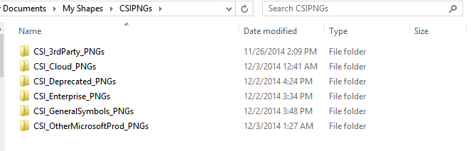

Then type in what you want to find. Once you find the right symbol, drag and drop it into PowerPoint.

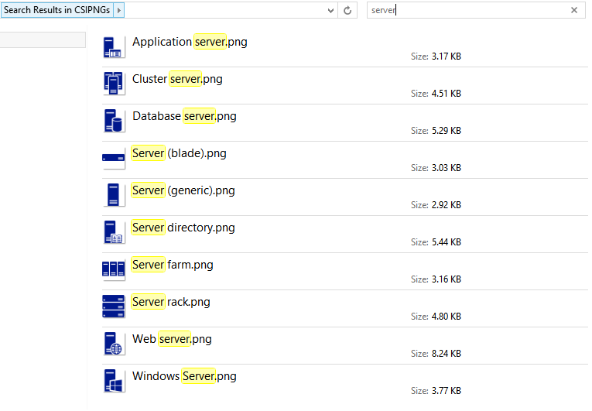

Use the FORMAT menu and the COLOR option to change the color of the symbols after they are in PowerPoint as shown in the picture below.

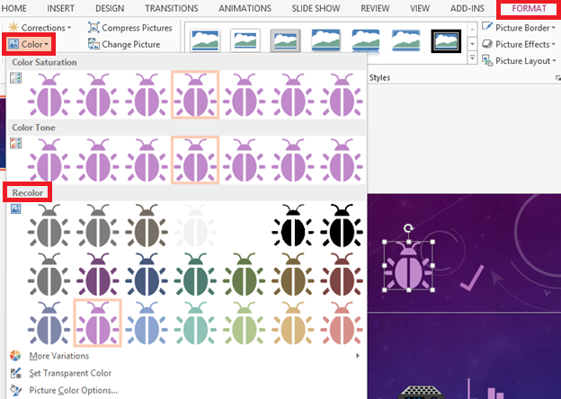

## Vector Objects in PowerPoint

You can create vector images in PowerPoint by cutting a vector object from Visio and using *Paste special > Picture (Enhanced Metafile)* from the PowerPoint menu. All shapes in the Visio stencils are vector shapes. Visio will also natively open SVG files, which are also in vector form. However, a normal drag and drop from Visio to PowerPoint will convert the shape to a PNG automatically.

In short remember these processes

**PNG**

1. Visio Stencil 🡪 Drag to Visio page 🡪 Drag to PowerPoint = **PNG only. Not vector.**
2. SVG 🡪 Drag into Visio sheet 🡪 Drag from Visio into PowerPoint presentation = **PNG only. Not Vector.**
3. SVG 🡪 Open in Visio 🡪 Drag from Visio into PowerPoint presentation = **PNG only. Not Vector.**

**Vector**

1. SVG or Visio Stencil 🡪 Drag into Visio sheet 🡪 Cut or copy shape from Visio 🡪 Use *Paste special > Picture (Enhanced Metafile)* in PowerPoint = **Vector object in PowerPoint format**. This keeps them vector images, so they will look better and the file size will be smaller. PowerPoint renders the pasted image as vector art.
2. Same #4, but then 🡪 Right-click object in PowerPoint and choose “Edit Picture” = **Vector object in *native* PowerPoint format.** Now you can change the color. Do NOT change the shape of the image at that is prohibited in the usage of the symbols. This usually works pretty well except on more complex images (things with transparencies/shadows/etc.,). In some of those instances, it’s easier to use the PNG form.

# **Instructions for Visio**

Also found in video training at <http://aka.ms/CnESymbolsVideo>

We suggest you set up Visio to use the Zoom options with the mouse wheel. It makes moving around large diagrams MUCH faster. Turn it on using the options below. Select any object on the diagram, use the mouse wheel, and you’ll see.



**Visio**

We suggest you set up Visio to use the Zoom options with the mouse wheel. It makes moving around diagrams MUCH faster. Turn it on using the options below. Select any object on the diagram, use the mouse wheel, and you’ll see.

The symbols are in Visio 2010 format so older versions of Visio can use them. Here’s a few tips. Video training is available at <http://aka.ms/CnESymbolsVideo>.

* **Open a new “blank” Visio diagram**. Opening a diagram of a specific type such as “flowchart” may change and recolor the icons when you drag them onto the page due to the use of Themes.
* **Symbol text.**  Once you drag and drop a symbol on to the page, it’s very easy to erase or change text. The symbol will remain highlighted after being dropped. If you click elsewhere, it will be un-highlighted, so just click on the symbols again ONCE to highlight it. Once the symbol is highlighted, the following actions will work.
* **To change** the text just start typing after dropping the symbol on the Visio page. The symbol will still be highlighted when you drop it, so any keystrokes erase the previous text and add your new text.
* **To erase all the text** just press a key to start adding text and then immediate press the “backspace” key to erase that one letter.
* **To modify the text,** press F2 and one of the arrow keys.
* **Fill and outline -** You can color the symbols that are not “stackable” very easily. You highlight them and then use the fill button to change the color. The Stackable symbols will not do this as easily as they are multi layered. If you fill them, you will get a large blob unless you click around to find the other layers in the symbol and fill those individually. The same holds true for change the outline. The Symbols do not come with outlines.



## Using in Other Applications

You can also drag and drop these symbols from Visio into other applications. Sometimes they will stay in vector form allowing you to make the symbols larger with no loss of quality. Other times they are converted into bitmaps. If the edges of a symbol lose their smoothness when you make them large, it’s likely that it has been converted to a bitmap format.

Visio can also save symbols into SVG (Scalable vector graphics) format. SVG can be imported into other applications such as Adobe Illustrator or InkScape. If you desire to have the set in another format, you are welcome to email [AzureSymbols@microsoft.com](mailto:AzureSymbols@microsoft.com) to see if that is available.

## Possible Issues using Visio

The stencil and Visio diagram are saved in 2003 to 2010 format to allow users with other versions to use them. However, behavior can vary between different versions of Visio. Always open a new “blank” Visio diagram. Opening a diagram of a specific type such as “flowchart” may change and recolor the symbols when you drag them onto the page. They are not protected from themes at this point.

Some arrows included are from stencils shipped with Visio.



On some systems, the wide arrows come up with a white background instead of a transparent background. You may need to reset the text block background using the paragraph section of the ribbon bar.

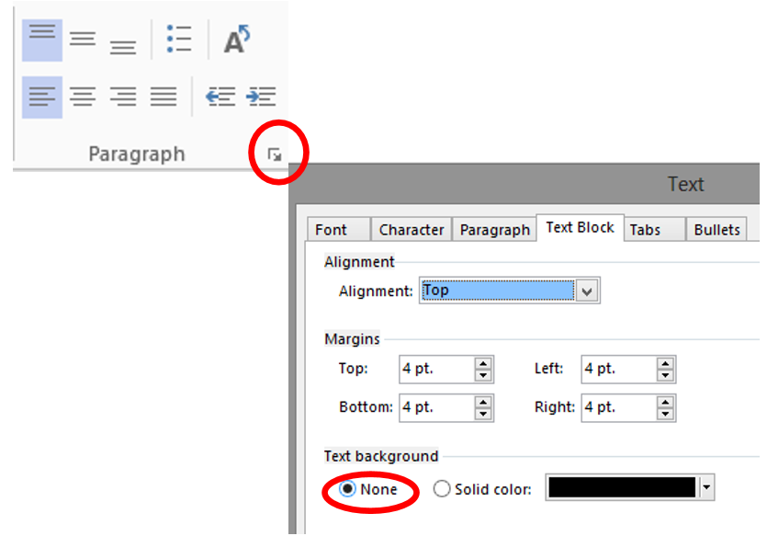

To use the Visio stencil file in Visio 2013:

1. Save the Visio stencil to your local machine.
2. Open a “blank” Visio document.
3. Open the stencil from the shapes pane as seen below.

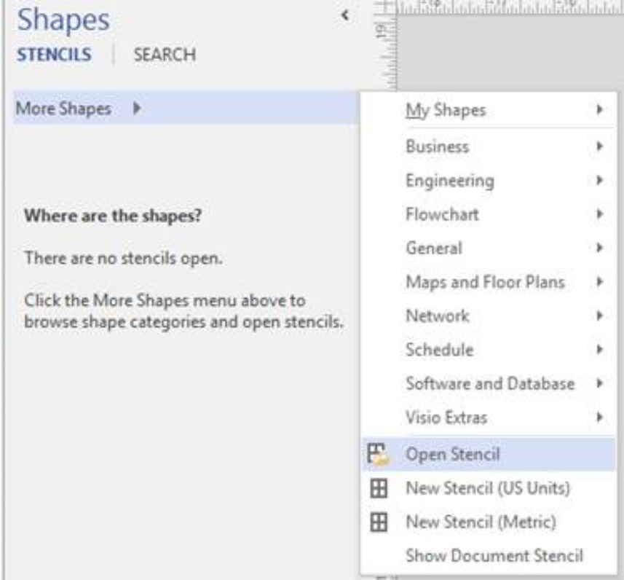

On some systems, you may also have to select “Show Document Stencil” at the bottom of the same menu.

These steps may be slightly different for other versions of Visio.

# PNG Export from Visio

A set of symbols in PNG form with a transparent background is also available. However, you can export your own PNGs using later versions of Visio. Select the symbol/picture that you want to export and then chose “Save As”. Use the values in this dialog as a guide for saving PNG symbols containing only a few solid colors. If you select entire diagrams, you can export those using higher resolutions in the “size” section. You may not want to use a transparency color in that case. If you use multiple colors, you may want to use the 256 color option.



If you use the supplied macro file (CSI_Art_Template_Save_*.vsdm), you can use a single keystroke to save individual symbols.

1. Ensure that you have downloaded the file from Microsoft so you will not have to worry about rouge macros.
2. Enable macros in the file.
3. Ensure you have a C:\temp directory on your computer.
4. Highlight a symbol.
5. CTRL-SHIFT+S will export the symbols in a 512x512 pixel format into C:\temp. Be sure to rename the file as subsequent exports will write over previous ones.

# SVG Export from Visio

Visio can export SVG format for symbols that are in that format and not in PNG form. Highlight ONLY the symbol you want to export and use “Save As” and chose SVG.

# Change History

===========FUTURE list =============

Requested

- IOT Suite http://azureiotsuite.com)

- NSG Network Security Group

- Privileged Identity Management - Square Person + cube

===========2016_8_08 2.5 release =============

 StoreSimple stencil added to bonus area.

CLOUD stencil clean up to fix bugs in 2.41

* Moved a number of icons from the cloud stencil to either depreciated or enterprise stencil to clean it up and make it mostly Azure services
* SVGs and PNGs in directory renamed for clarity. Stencils were not because longer name would make it hard to find. Some Visio shapes still lack connection points and text.
* 4 copies of most icons now exist in the CLOUD directory.
  + A monochrome SVG and PNG
  + A color PNG and PNG. Sometime there is no color version and so these are absent.

===========2016_6_29 2.41 release =============

More items than this have been changed, but these are the major changes.

Changed

- Move ACS to deprecated area

- Backup Service to Backup Agent (clock) and Azure Backup (no clock)

- Visual Studio Online renamed to Visual Studio Team Services

- Azure Automation opaque text box fixed- f2 works now.

- Site Recovery matches portal. Arrow from top to bottom vs. bottom to top for Backup

- CDN to "fast cloud" from "lightening cloud"

- VM Scale Sets. Use old availability set icon. New Availability set icon created instead.

- file server corrected in VMs by function template.

- Service Bus, Service Bus Relay, Service Bus Queues, Service Bus Topics have new easier to read and distinguish symbols

Added

- Dump of all the SVG icons from the newest Azure Management Portal (formerly codenamed Ibiza). SVGs can be opened in Visio and then treated like any Visio shape.

- Colored numbers to CnE_General. PNG only.

- Shadowed colored spheres and Xs for using in Web tables to CnE_General. PNG only.

- App Gateway to new icon. Old is just generic gateway

- Azure AD B2C - Use same as Azure AD

- Azure AD Directory Domain services. - Use same as Azure AD

- AD Health Monitoring - Azure AD + Heart

- Azure Functions

- Cognitive Services API

- Cortana Analytics

- Container Service

- Data Catalog

- Data Lake - matches portal now

- Data Lake Storage - matches portal now

- Data Lake Analytics - matches portal now

- Dev Test Labs

- DocDB sub icons and some changed to text for originals

- Hockey App

- Management Portal

- Power BI Embedded

- PowerApps

- Security Center

- SQL Data Warehouse

- SQL Server Stretch Database

- IOT hub

- Web Hooks (org icon)

Microsoft

- Cortana product icon

3rd Party

- Linux Penguin (color and not)

- Redis

NDA and Microsoft Internal

- HyperNet

Added information on how to convert shapes from Visio into native PowerPoint symbols.

Added colored numbers to the PNG area. 4 different colors 1-20. Opaque.

===========2015_12_09 =============

Added

Waiting symbol

Shadow box

"Contains" shadow box

Server "Contains" shadow box

Azure Automation opaque text box fixed- f2 works now.

===========2015_10_12=============

Added new services/features

Azure IOT Hub

Azure Datalake

Azure VPN Gateway

Service Fabric

Azure DNS

Azure load balancer. Old one changed to Azure load balancer (automatic).

Resource Group

Microsoft Windows symbol

Microsoft Intune and System Center symbols added

Bugs fixed or changes

Virtual Machine Container - removed monitor symbol to make simpler

Virtual network box. Didn't work right when stretched. Made a smart version and a simple version

Excel icon had "Exel" for the text.

Azure Virtual Network changed to look better

Microsoft Azure icon color changed to blue to be consistent

"Code file" symbol changed to have func() in it. Old code file with {} now used for DocumentDB file to be consistent with other symbols.

Added BONUS area

3D Blueprint Visio Template

Windows Server Service Containers PowerPoints

Patterns and Practices icons PNG form

Added Macro Visio template

(CSI_Art_Template_Save_v2.31) so you can export you own art using a single keystoke. (SHIFT-CTRL-A)

Corrected

Known bugs

DNS symbol lines are not clean.